Andhra Bank :

BUSINESS DETAILS:

* The products and services provided by the bank are mainly categorized into businesses of Retail, Corporate, NRI, MSME, and Agricultural industries.
* Under the Retail Business, the bank offers Deposits, Loans, Cards, DMAT Services, Payment Services, Insurance, and Mutual Funds to individual customers.
* Under the Corporate Business, the bank offers Loans & Advances, Project Appraisal services, and Syndication of Loans to the business entities.
* Under the NRI business segment, the bank offers Deposit schemes, Loans, Remittance services, and Investment services to the Non-Resident Indians.
* Under theMSME business segment, the bank offers different schemes that aimed at providing loan and transaction services to Micro Small and Medium Enterprises (MSME).
* Under the Agriculture business segment, bank provides different credit schemes to farmers, Women Empowerment schemes, and Andhra Bank Rural Development Trust (ABRDT) helps Rural Self Employment Training Institutes.
* Following are the various Deposit Schemes available :

AB Savings Accounts

AB Current Accounts

AB Term Deposits

AB Arogyadaan Scheme

AB Bancassurance Life

AB Bancassurance (Non-Life)

Retail Loans

Agricultural Loans

Corporate Banking

NRI Banking

NRI Products and Services

NOSTOR details for remittance

Western Union Money Transfer

PROBLEM STATEMENT:

* To study the financial performance of Andhra Bank and Union Bank during pre- post-merger period.

INTRODUCTION:

* On 30 August 2019, Finance Minister Nirmala Sitharaman announced that Andhra Bank and Corporation Bank would be merged into Union Bank of India.
* Union Bank had merged with Andhra Bank and it came into effect from **April, 2020**. The merger has significantly resulted in improving the geographical penetration of Union bank across the country.
* Union Bank of India is the fifth largest public sector bank in the country with assets of ₹14.59 lakh crore (US$180 billion) and 9,609 branches.
* The agricultural NPAs have spoiled the asset quality of Andhra Bank.

ANALYSIS:

Data Collection:

|  |  |  |  |  |  |  |  |  |
| --- | --- | --- | --- | --- | --- | --- | --- | --- |
| UPI Banks | Volume (Mn) By Costumers | Value (Cr) by Costumers | Volume (Mn) | Value (Cr) | Month |  | Val per Tx by customer | Value per Tx |
| Andhra Bank App | 0.02 | 13.32 | 0.02 | 13.32 | 1(Jan) |  | 666 | 666 |

Financial Analysis:

SOLUTIONS/RESULTS:

* Mobilize more CASA balance increase as low-cost sources of funds for banks which bank can utilize. The more transactions customers conduct through these accounts, the more opportunities there are for banks to earn fees from services like overdraft facilities, checkbooks, debit cards, and transaction charges.
* By maintaining a strong relationship with CASA account holders, banks can increase their fee-based income like account maintenance charges etc.
* Cross-sell other financial products and services to their customers, such as MF, loans, credit cards, investment products, and insurance
* Disburse more loans to MSME and salaried employees to improve revenue and profits with proper due diligence
* Let out more lockers so that bank can earn with fees and commission
* Keeping minimum cash and do efficient cash management via proportional investments in treasury bonds and govt securities and MF, so that money is not stuck in idle asset i.e. cash and will help generate more income.
* Reduce the number of branches where there are comparatively a smaller number of accounts and shift them to nearby branches so that infrastructure cost can be reduced.
* Employ contractual agents by outsourcing them for other banks and generate income

INTEPRETATION/CONCLUSION:

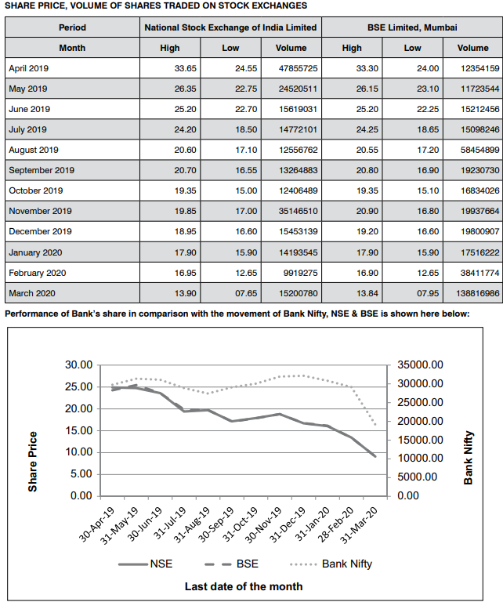

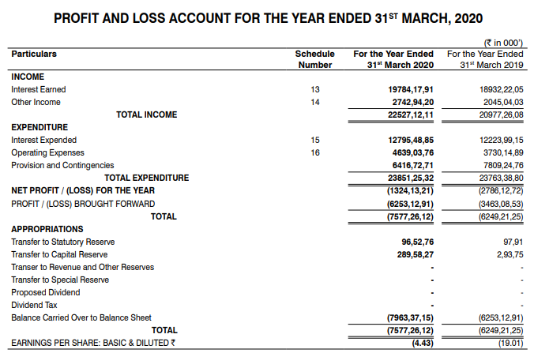

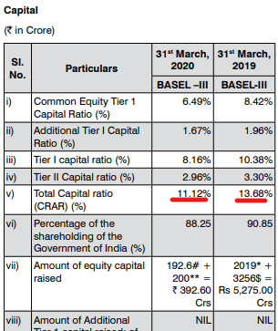

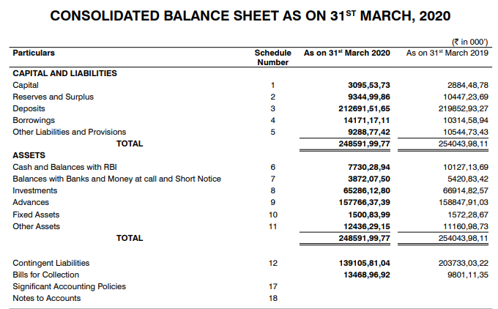

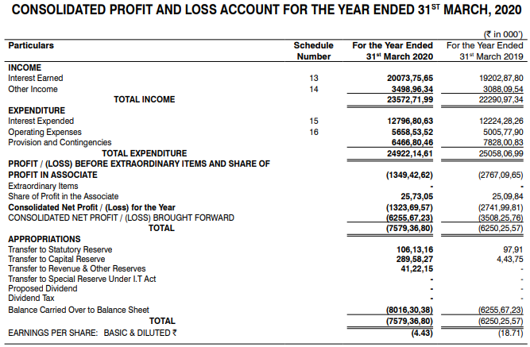

**For 18-19:**

Total Income for the financial year 2018-19 of the bank stood at Rs. 20,977 Cr as compared to Rs. 20,347 Cr for FY 2017-18. The Non interest income of the bank stood at Rs. 2045 Cr. Operating Prot of the Bank stood at Rs.5023 Cr compared to Rs.5361 Crore in the previous year. However, on account of higher provisioning towards ageing of NPAs, the Bank incurred a Net Loss of Rs. 2786 Cr for FY

2018-19 as compared to Net Loss of Rs. 3412 Cr for FY 2017-18. The Total interest income of the Bank stood at Rs. 18,932 Cr as compared to Rs. 17974 Cr of the previous year. Of this, Interest Income from Advances registered an increase by 8.44% from Rs.13069 Cr during 2017 18 to Rs. 14,173 Cr in 2018-19. Interest Income from investments stood at Rs. 4,672 Cr in 2018-19. Total Expenses during the financial year 2018-19 is Rs. 15,954 Cr against Rs.14985 Crore registered during the previous year. The interest expenditure increased by 5.02 % from Rs.11,640 Cr in 2017-18 to Rs. 12,224 Cr in 2018-19. The, Operating Expenses stood at Rs.3,730 Crore, registering an increase of 11.48% over the previous year.

